Big Al in the Lab
Bycatch Game

Time: 12 minutes
Group Size: 8-15 students
Grade Levels: 2nd – 3rd grade
Location: Sahm Marine Education Center

OVERVIEW OF ACTIVITY

Students will be introduced to the idea of net fishing and they must discover the benefits and consequences of net fishing. They will play a bycatch game to collect as many fish (poker chips) as they can from the ocean. Little do they know, the different colors of the poker chips are varying animal species in the ocean. Some of the chips may be sea turtles, sharks, dolphins, etc., while a majority are fish. Students will see how taking as many “fish” as they want has the repercussion of bycatch. After playing the game, students will discuss possible solutions to net fishing that would lessen/eliminate bycatch.

PERFORMANCE OBJECTIVES

Students will be able to:
- Collect and analyze data pertaining to net fishing and bycatch.
- Understand what bycatch means.
- Propose solutions to net fishing that would lessen/eliminate bycatch.

CHALLENGE

Play the fishing game in order to understand the concept of bycatch and then propose ideas on how to lessen/eliminate bycatch in the future.

MATERIALS
- Colored chips
- Four empty boxes
- Four hand-held 3” fish nets
- Four laminated category grids (for categorizing chips)
- Laminated sheet from Big Al of fish in fisherman’s net
- Laminated key for colored chips
- Laminated sheet with ocean-friendly labels
- Laminated Bycatch sheet
- Laminated Line Fishing sheet

ADVANCE PREPARATION
- During set up, push two lab tables together to form one large table. Set up four stations around the table with a box full of colored chips, one fish net, and one categorizing grid at each station.
- Do not let the students see the color key for the chips. They need an unbiased view when “fishing.”
- Make sure students are sharing in their groups and one isn’t doing all of the work.

PROCEDURE

Engage:
- Sit the students down and show them the laminated sheet from Big Al showing all of the fish stuck in the fisherman’s net. What is happening in this picture? (Big Al is watching all of the fish caught in the fisherman’s net). What is the fisherman using to catch these fish? (a net). Do you think this is the best way to catch fish? Why? (Answers will vary. Net fishing is a way to catch a lot of fish/animals at once, but a lot of bycatch occurs with this method). Do you think other animals can get stuck in the net that aren’t fish? What animals? What happened to Big Al after he was caught? Why? (the fisherman threw him back into the ocean because he was not what the fisherman intended to catch).
- We are going to play a game where we get to go fishing to see how many fish we can catch with one net.

Explore:
- The poker chips on the table represent animals in the ocean. You will be fishing for as many fish as you can, using a net fishing.
- Split the students into four groups. Each group will have one net scooper and one container full of colored plastic chips. One student from the group will scoop once to collect as many chips as they can and place them on the table in front of them.
- After they have scooped chips, have the students count the total they collected. Ask each group how many total they collected.
- Tell the students that each plastic chip’s color determines what type of animal they collected. Show students a color key diagram that differentiates what each poker chip is-- green is a sea turtle, blue is a marine mammal, orange is a fish, and gray is a shark.
- Have the students separate their poker chips by color and place them on their corresponding square on the laminated grid. Have them count how many they have of each.
- Explain bycatch. Students can attempt to scoop again for just the orange chips but will find that it is nearly impossible with a net. This will reiterate the difficulty of net fishing for one type of organism. You can ask them how they can catch only fish with little to no bycatch. Students can attempt to line fish using their hands (if you have time).
- While going through the explain and extend questions, make sure to show the students the dolphin-friendly labels laminate.

Explain and Extend:
- What technique did you use to catch your fish? Did you pick them up one by one or did you fill your net?
- Which color did you have the most of? What does that mean?
- How much of your collection was bycatch? (Students must add up all poker chips except for the orange ones) How does that make you feel?
- Look at the picture of all of the fish in the fisherman’s net. Do you see any bycatch in the net? Do you think there could be bycatch in the net?
- What would you do to help eliminate bycatch when fishing? What are some other ways to fish? (Line-fishing is a better solution because you are only fishing for one animal at a time).
- What can you do in your everyday life to help with this problem? (Read ecolabels on food indicating “dolphin-friendly” or “line-caught.” This ensures that less animals were harmed in the collection of market food.)

Evaluate:
- What did you like about the bycatch game? Why? (Answers will vary)
- What did you dislike about the bycatch game? Why? (Answers will vary)
- What was the most difficult part of the game? (Answers will vary)
- How did you overcome the difficulty? (Answers will vary)

ACTIVITY RESOURCES

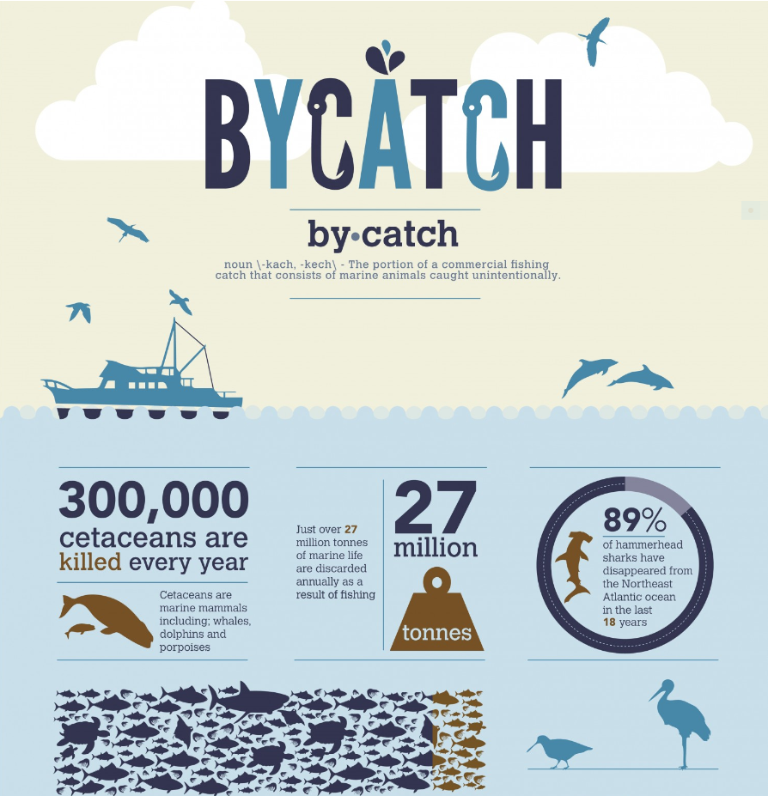
Bycatch Grid for Sorting Chips


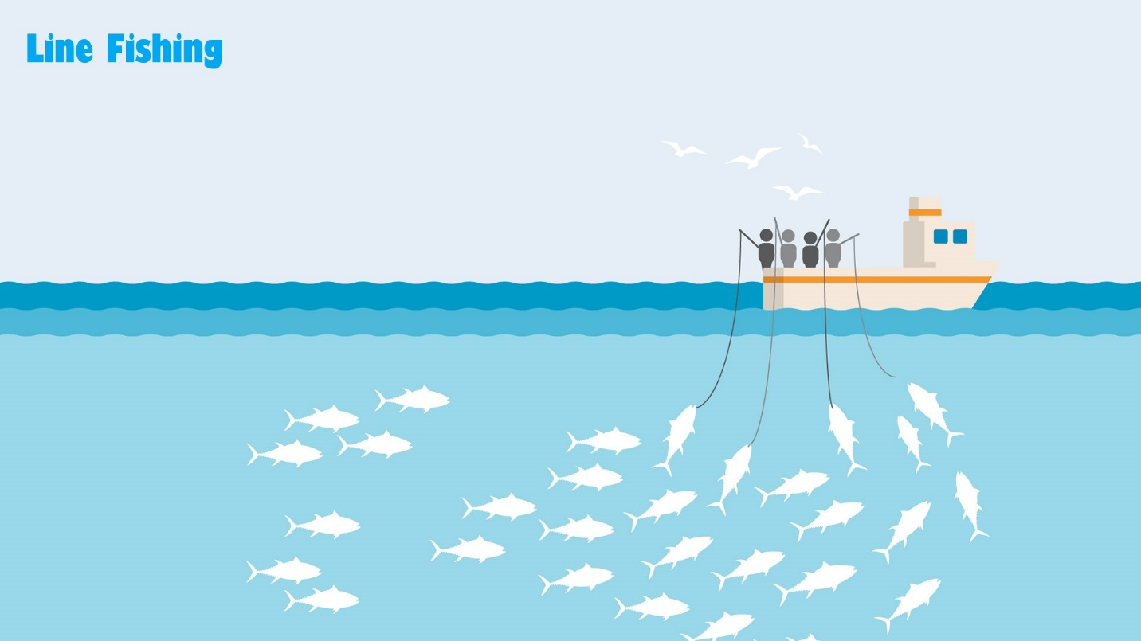

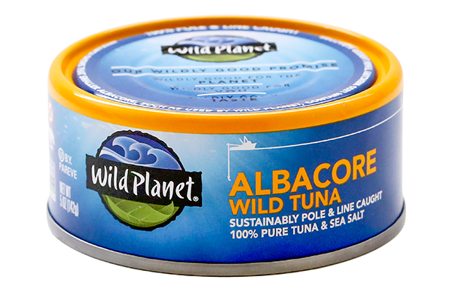

BACKGROUND INFO

VOCABULARY
Bycatch- the unwanted fish and other marine creatures caught during commercial fishing for a different species. It is either of a different species, the wrong sex, or is undersized or juvenile individuals of the target species.

Ecolabel- identifies products or services proven environmentally preferable overall, within a specific product or service category. Ecolabelling is a voluntary method of environmental performance certification and labelling that is practiced around the world. Labels include “dolphin-friendly” and “line-caught.”

The highest rates of incidental catch of non-target species are associated with shrimp trawling. Trawl nets in general, and shrimp trawls in particular, have been identified as sources of mortality for cetacean and finfish species. When bycatch is discarded (returned to the sea), it is often dead or dying.

Cetaceans, such as dolphins, porpoises, and whales, can be seriously affected by entanglement in fishing nets and lines, or direct capture by hooks or in trawl nets. Cetacean bycatch is increasing in intensity and frequency.
One example of bycatch is dolphins caught in tuna nets. As dolphins are mammals and do not have gills they may drown while stuck in nets underwater. This bycatch issue has been one of the reasons of the growing ecolabelling industry, where fish producers mark their packaging with disclaimers such as "dolphin friendly" to reassure buyers. However, "dolphin friendly" does not mean that dolphins were not killed in the production of a particular tin of tuna, but that the fleet which caught the tuna did not specifically target a feeding pod of dolphins but relied on other methods to spot tuna schools. The bycatch of the Caspian seal may be recognized as the one of the biggest entanglements of pinnipeds as bycatch in the world. The Caspian seal population has declined by more than 90% since 1900 and is listed as endangered by IUCN. A study by Lilia Dmitrieva documented a minimum by-catch of 1,215 seals for the 2008-2009 fishing season. (https://journals.plos.org/plosone/article?id=10.1371/journal.pone.0067074)
Sea turtles, already critically endangered, have been killed in large numbers in shrimp trawl nets. Estimates indicate that thousands of Kemp's Ridley, loggerhead, green and leatherback sea turtles are caught in shrimp trawl fisheries in the Gulf of Mexico and the US Atlantic annually. The speed and length of the trawl method is significant because, “for a tow duration of less than 10 minutes, the mortality rate for sea turtles is less than one percent, whereas for tows greater than sixty minutes the mortality rate rapidly increases to fifty to one hundred percent.”
Sharks are top predators that play a crucial role in maintaining healthy and balanced marine ecosystems. Yet they are also extremely vulnerable to overexploitation and continue to be caught in large numbers in U.S. and international fisheries. Fishermen captured 12 million sharks and rays as bycatch each year throughout the 1990s in international waters alone. Researchers recently estimated that as many as 100 million sharks are still caught and killed each year around the world due to bycatch, illegal fishing and the persistent demand for shark fins. Prohibiting certain highly depleted shark species from being landed in the U.S. is one way to minimize bycatch mortality, because such prohibited species must be released back into the water if they are still alive when caught.
Unfortunately, too many species of sharks are still caught at an unsustainable rate, further depleting vulnerable populations and hindering recovery. Longline fisheries catch sharks instead of the intended target at least 20 percent of the time, with some estimates as high as 50 percent for Atlantic and Hawaiian fisheries. The continued depletion of shark species in the U.S. and around the world highlights the importance of stronger regulations to minimize bycatch.

Additional Resource- https://oceana.org/sites/default/files/reports/Bycatch_Report_FINAL.pdf

